Odoo 15 Assigning New Domain
1 - Create a .conf file with your database name inside etc/ (odoo15-dbname for better naming convention)
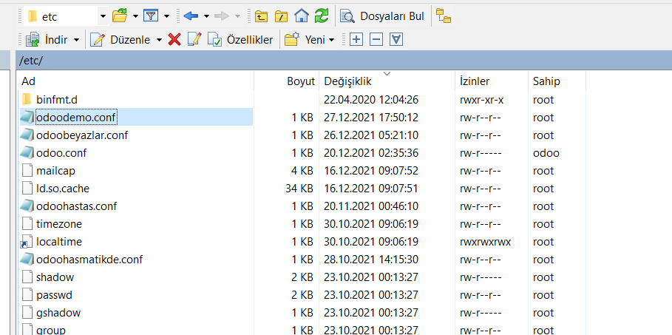
2 - Now paste the information below inside the .conf file. Change port numbers to something that’s not used by other dbs. Dbfilter must be the name of the db.
[options]
proxy_mode = True
; This is the password that allows database operations:
addons_path = /odoo/odoo15/odoo/odoo/addons,/odoo/odoo15/odoo/addons,/odoo/odoo15/odoo-custom-addons
admin_passwd = MyStr0ngAdminP@ssw0rd
db_host = False
db_port = False
db_user = odoo
db_password = False
xmlrpc_port = 8069
longpolling_port = 8072
workers = 2
;dbfilter = panel
;proxy_mode = true
logfile = /var/log/odoo/odoo.log
;logrotate = True
3 – Run this command. It will create .service file for the db:

sudo nano /etc/systemd/system/dbname.service
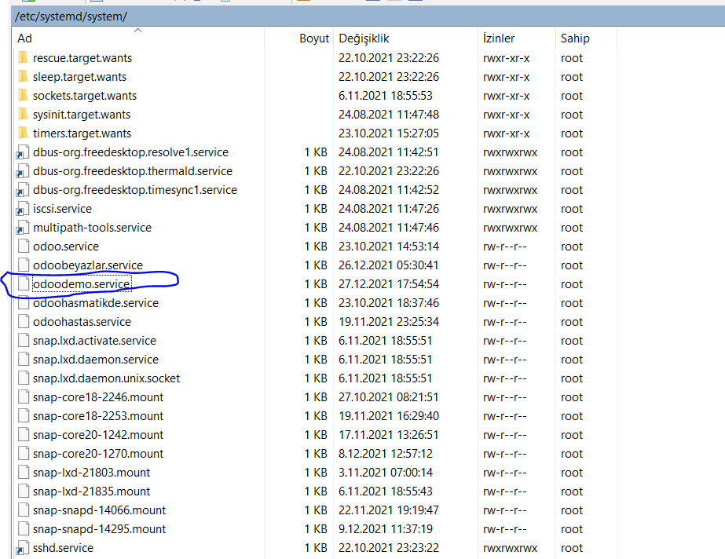
4 – Put this information in the .service file. Rename the corresponding fields :

[Unit]
Description=Odoo15-dbname
Requires=postgresql.service
After=network.target postgresql.service
[Service]
Type=simple
SyslogIdentifier=odoo15-dbname
PermissionsStartOnly=true
User=odoo
Group=odoo
ExecStart=/odoo/odoo-venv/bin/python3 /odoo/odoo/odoo-bin -c /etc/odoo15-dbname.conf
StandardOutput=journal+console
[Install]
WantedBy=multi-user.target

5 – Run this command to start the service :

sudo systemctl enable --now odoodemo
6 – Create a new file in the etc/nginx/sites-available/ using this command, change the last part according to your domain (e.g modem.nitrawork.com, www.autoronics.com):

sudo nano /etc/nginx/sites-available/name.domain.com
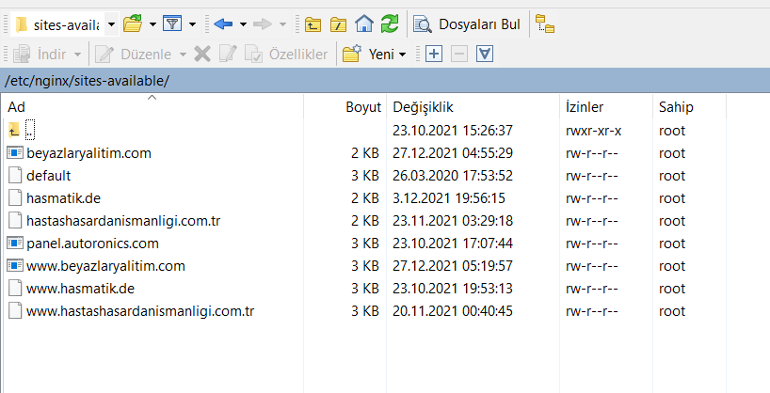
7 – Put the information below inside the .com file :
server {
listen 80;
server_name name.domain.com;
include snippets/letsencrypt.conf;
}

8 – Run this command to create the shortcut of the .com inside the sites-enabled folder:

sudo ln -s /etc/nginx/sites-available/www.autoronics.com /etc/nginx/sites-enabled/
9 – Test nginx

nginx –t
10 – If successful, run this command to restart nginx:
sudo systemctl restart nginx
Kurulum Gerekirse:
apt install python3-certbot-nginx

11 – Now run this command to create the certificate

sudo certbot --nginx --agree-tos --email your@email --redirect --hsts -d name.domain.com

12 – Now open the .com file of your domain in the /etc/nginx/sites-available/your.com and paste this code if your domain have www, change the fields accordingly:

upstream odoorush{
server 127.0.0.1:6099;
}

upstream odoorushchat{
server 127.0.0.1:6098;
}

#HTTP -> HTTPS
server {
listen [::]:80;
listen 80;
server_name www.rushbeautysalon.com rushbeautysalon.com;
return 301 https://$host$request_uri;
}

server {
listen 443 ssl http2;
server_name www.rushbeautysalon.com;

proxy_read_timeout 720s;
proxy_connect_timeout 720s;
proxy_send_timeout 720s;

# Proxy Headers
proxy_set_header X-Forwarded-Host $host;
proxy_set_header X-Forwarded-For $proxy_add_x_forwarded_for;
add_header Content-Security-Policy upgrade-insecure-requests;

#SSL CERTICATION
ssl_certificate /etc/letsencrypt/live/www.rushbeautysalon.com/fullchain.pem; # managed by Certbot
ssl_certificate_key /etc/letsencrypt/live/www.rushbeautysalon.com/privkey.pem; # managed by Certbot
ssl_trusted_certificate /etc/letsencrypt/live/www.rushbeautysalon.com/chain.pem;
include snippets/ssl.conf;
include snippets/letsencrypt.conf;

# log files
access_log /var/log/nginx/odoo.access.log;
error_log /var/log/nginx/odoo.error.log;

# Specifies the maximum accepted body size of a client request,
# as indicated by the request header Content-Length.
client_max_body_size 200m;

# increase proxy buffer to handle some odoo web requests
proxy_buffers 16 64k;
proxy_buffer_size 128k;

# Handle long poll requests
location /longpolling {
proxy_pass http://odoorushchat;
}

# Handle / requests
location / {
proxy_redirect off;
proxy_pass http://odoorush;
}

# Cache static files
location ~* /web/static/ {
proxy_cache_valid 200 90m;
proxy_buffering off;
expires 864000;
proxy_pass http://odoorush;
}
# Gzip
gzip_types text/css text/less text/plain text/xml application/xml application/json application/javascript;
gzip on;

}

server {
listen 443 ssl http2;
server_name rushbeautysalon.com;

proxy_read_timeout 720s;
proxy_connect_timeout 720s;
proxy_send_timeout 720s;

# Proxy Headers
proxy_set_header X-Forwarded-Host $host;
proxy_set_header X-Forwarded-For $proxy_add_x_forwarded_for;
add_header Content-Security-Policy upgrade-insecure-requests;

# SSL parameters
ssl_certificate /etc/letsencrypt/live/rushbeautysalon.com/fullchain.pem;
ssl_certificate_key /etc/letsencrypt/live/rushbeautysalon.com/privkey.pem;
ssl_trusted_certificate /etc/letsencrypt/live/rushbeautysalon.com/chain.pem;
include snippets/ssl.conf;
include snippets/letsencrypt.conf;

access_log /var/log/nginx/odoo.access.log;
error_log /var/log/nginx/odoo.error.log;

# Specifies the maximum accepted body size of a client request,
# as indicated by the request header Content-Length.
client_max_body_size 200m;

# increase proxy buffer to handle some odoo web requests
proxy_buffers 16 64k;
proxy_buffer_size 128k;

# Handle long poll requests
location /longpolling {
proxy_pass http://odoorushchat;
}

# Handle / requests
location / {
proxy_redirect off;
proxy_pass http://odoorush;
}

# Cache static files
location ~* /web/static/ {
proxy_cache_valid 200 90m;
proxy_buffering off;
expires 864000;
proxy_pass http://odoorush;
}
# Gzip
gzip_types text/css text/less text/plain text/xml application/xml application/json application/javascript;
gzip on;

}

If not, use this instead:

upstream odooserverdemotransfer{
server 127.0.0.1:8039;
}

upstream odoochatdemotransfer{
server 127.0.0.1:8040;
}

#HTTP -> HTTPS
server {
listen [::]:80;
listen 80;
server_name havalimanitransferyazilimi.autoronics.com;
return 301 https://$host$request_uri;
}

server {
listen 443 ssl http2;
server_name havalimanitransferyazilimi.autoronics.com;

proxy_read_timeout 720s;
proxy_connect_timeout 720s;
proxy_send_timeout 720s;

# Proxy Headers
proxy_set_header X-Forwarded-Host $host;
proxy_set_header X-Forwarded-For $proxy_add_x_forwarded_for;
add_header Content-Security-Policy upgrade-insecure-requests;

#SSL CERTICATION
ssl_certificate /etc/letsencrypt/live/havalimanitransferyazilimi.autoronics.com/fullchain.pem; # managed by Certbot
ssl_certificate_key /etc/letsencrypt/live/havalimanitransferyazilimi.autoronics.com/privkey.pem; # managed by Certbot
ssl_trusted_certificate /etc/letsencrypt/live/havalimanitransferyazilimi.autoronics.com/chain.pem;
include snippets/ssl.conf;
include snippets/letsencrypt.conf;

# log files
access_log /var/log/nginx/odoo.access.log;
error_log /var/log/nginx/odoo.error.log;

# Specifies the maximum accepted body size of a client request,
# as indicated by the request header Content-Length.
client_max_body_size 200m;

# increase proxy buffer to handle some odoo web requests
proxy_buffers 16 64k;
proxy_buffer_size 128k;

# Handle long poll requests
location /longpolling {
proxy_pass http://odoochatdemotransfer;
}

# Handle / requests
location / {
proxy_redirect off;
proxy_pass http://odooserverdemotransfer;
}

# Cache static files
location ~* /web/static/ {
proxy_cache_valid 200 90m;
proxy_buffering off;
expires 864000;
proxy_pass http://odooserverdemotransfer;
}
# Gzip
gzip_types text/css text/less text/plain text/xml application/xml application/json application/javascript;
gzip on;

}

If you have both:

upstream odooserverantrivaviptransfer{
server 127.0.0.1:8085;
}

upstream odoochatantrivaviptransfer{
server 127.0.0.1:8086;
}

#HTTP -> HTTPS
server {
listen [::]:80;
listen 80;
server_name antrivaviptransfer.com www.antrivaviptransfer.com;
return 301 https://antrivaviptransfer.com$request_uri;
}

server {
listen 443 ssl http2;
server_name antrivaviptransfer.com www.antrivaviptransfer.com;

proxy_read_timeout 720s;
proxy_connect_timeout 720s;
proxy_send_timeout 720s;

# Proxy Headers
proxy_set_header X-Forwarded-Host $host;
proxy_set_header X-Forwarded-For $proxy_add_x_forwarded_for;
add_header Content-Security-Policy upgrade-insecure-requests;

#SSL CERTICATION
ssl_certificate /etc/letsencrypt/live/antrivaviptransfer.com/fullchain.pem; # managed by Certbot
ssl_certificate_key /etc/letsencrypt/live/antrivaviptransfer.com/privkey.pem; # managed by Certbot
ssl_trusted_certificate /etc/letsencrypt/live/antrivaviptransfer.com/chain.pem;
include snippets/ssl.conf;
include snippets/letsencrypt.conf;

# log files
access_log /var/log/nginx/odoo.access.log;
error_log /var/log/nginx/odoo.error.log;

# Specifies the maximum accepted body size of a client request,
# as indicated by the request header Content-Length.
client_max_body_size 200m;

# increase proxy buffer to handle some odoo web requests
proxy_buffers 16 64k;
proxy_buffer_size 128k;

# Handle long poll requests
location /longpolling {
proxy_pass http://odoochatantrivaviptransfer;
}

# Handle / requests
location / {
proxy_redirect off;
proxy_pass http://odooserverantrivaviptransfer;
}

# Cache static files
location ~* /web/static/ {
proxy_cache_valid 200 90m;
proxy_buffering off;
expires 864000;
proxy_pass http://odooserverantrivaviptransfer;
}
# Gzip
gzip_types text/css text/less text/plain text/xml application/xml application/json application/javascript;
gzip on;

}

13 – Restart the odoo service of your db:

sudo systemctl restart odoodemo

14 – Test nginx:

nginx –t

15 – Make sure it’s successful and wait around 15-20 secs and run this command to restart nginx:

sudo systemctl restart nginx
DONE

BELOW INFO IS FOR WHEN YOU NEED THEM:

Renewing SSL automatically:

certbot --force-renewal -d www.nixcraft.com,nixcraft.com
nginx –t

sudo systemctl restart nginx
- Continue by pressing 2

If you hit a dead end, especially when you get 502 Gateway error, check the status of the service that’s running, this command will print the error:

sudo systemctl status odoo15-demotrans

https://medium.com/@othmane.ghandi/running-odoo-in-https-using-nginx-certbot-90ef2f3e5ccb

